Assignment 3

- Define and describe the differences between hubs, switches and routers.
Hub is a layer 1 (physical layer) device, is also a multiple-port repeater, so it won’t check the content or frame of the message, it will only repeat it and magnify the frequency.
Switch is a layer 2 (data link layer) device, is also a multiple-port bridge, so it will check the content or frame of the message and forwards data only to the appropriate port for the intended recipient.
Router is a device that forwards data packets between computer networks. Packets are forwards between routers and routers use routing table to determine where to forward a data packet.

- Briefly describe how a host or router can determine the MAC address of another host B when knowing B’s IP address? (Hint: ARP protocol)
When a host or router want to send datagrams to B but it doesn’t know B’s MAC address, it will broadcast ARP query frame, which contains B’s IP address, and all machines on LAN will receive this ARP query. When B receives this ARP frame, it will reply to the host or router with its MAC address, and this MAC address will be added into the host or router’s ARP table

- Spell out and define/describe CSMA/CD.
The full name for CSMA/CD is Carrier Sense Multiple Access with Collision Detection
Because when a NIC wants to transmit, it should listen for traffic (Carrier Sense)
If there is no traffic, then NIC may transmit. If there is traffic, the NIC must wait until no traffic is being transmitted, then it can start to transmit.
When there is a collision, all NICs stop transmitting and wait for a random amount of time, the first NIC that finishes its wait will begin to transmit when there is no traffic, otherwise it needs to wait until there is no traffic. If there are multiple collisions, the random wait is increased each time. After 16 times, the sending NIC discards the frame.

- Refer to the following diagram. Host_A is attempting to contact Server_B. In this process, Host_A will generate a packet with the destination IP address of which device (e.g., Router_A or server_B)? Host_A will then generate a frame with the destination MAC address of which device (e.g., Switch_A, Router_A. or Server_B)? Briefly describe the difference between IP address (IPv4) and MAC address.
- Server B
- Router A
- MAC address: is used to get frame from one interface to another physically-connected interface (same network) and is usually expressed for humans in hexadecimal, base 16-each symbol represents 4 bits, convert each 4 bits to a hex symbol from 0 to F. It’s unique and portable.
IP address: is an identifier assigned to each computer and other device connected to a TCP/IP network, it’s used to locate and identify nodes in communication. It’s usually written in human-readable notations, 32 bits, all numbers. Since the IP address depends on which node it is attached to, it’s not unique, and it’s not portable.
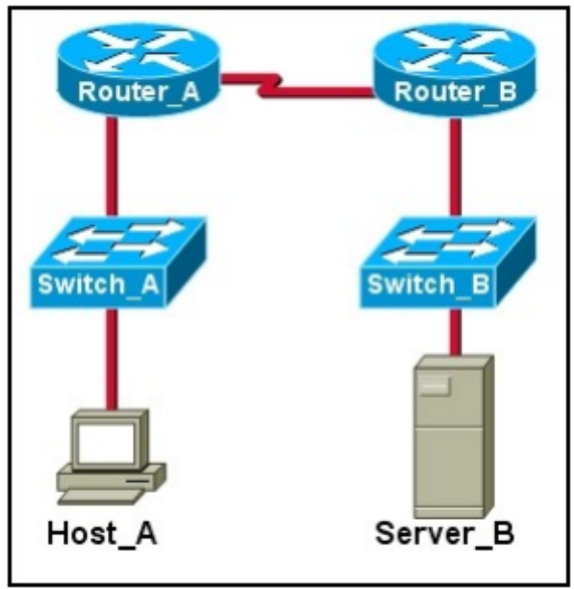

- Spell out and define VLAN. Describe the benefits of implementing VLANs.
VLAN is short for virtual LAN (local area network). It’s any broadcast domain that is partitioned and isolated in a computer network at the data link layer. It’s a grouping of network devices that is not restricted to a physical switch.
Using a VLAN, it’s easier to add and move stations on the LAN, it’s also easier to reconfigure the LAN, and there is better traffic control. There is also increased security.

- Spell out and explain DWDM.
DWDM is short for Dense wavelength division multiplexing. It is a technology that puts data from different sources together on an optical fiber, with each signal carried on its own separate light wavelength. It can reach a higher speed

